Game Design Document

Fill up the following document

1. Write the title of your project.

Aquaria game

1. What is the goal of the game?

The player has to collect the required food items

1. Write a brief story of your game.

This is an aquarium game, where fishes are the players and they have to collect the food and save themselves from obstacles.

1. Which are the playing characters of this game?

* Playing characters are the ones who respond to the user based on the input from the user.
* Cars, monkeys, dinos, wizards, etc., are the playing characters in the game.

|  |  |  |
| --- | --- | --- |
| Number | Character Name | What can this character do? |
| 1 | fishes | They can eat food  They can move up and down |
| 2 |  |  |
| 3 |  |  |
| 4 |  |  |
| 5 |  |  |
| 6 |  |  |
| 7 |  |  |
| 8 |  |  |

1. Which are the Non-Playing Characters of this game?

* Non-Playing characters are the ones that don't have an action or behavior when the user interacts with the game.
* Hurdles, stones, bananas, coins, etc., are non-playing characters in the game.

|  |  |  |
| --- | --- | --- |
| Number | Character Name | What can this character do? |
| 1 |  |  |
| 2 |  |  |
| 3 |  |  |
| 4 |  |  |
| 5 |  |  |
| 6 |  |  |
| 7 |  |  |
| 8 |  |  |

Draw your imagination of this game. What does this game look like?

* Draw the game either on your computer or on paper.
* Add images of the game scenes to show each of the playing and non-playing characters at least once.

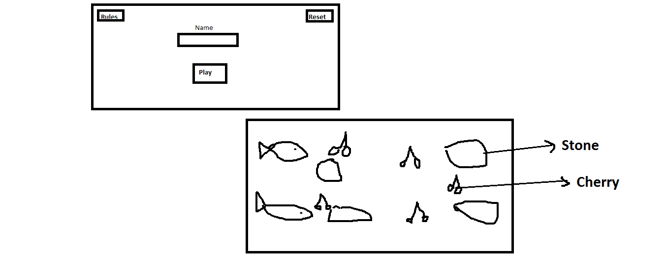

How do you plan to make your game engaging?

The player has to collect the food items while saving themselves from the obstacles, si its a challenge for them to save themselves at the same time when they'll eat food.